**ASSIGNMENT- 5**

1. LIFE CYCLE ANALYSIS

Life Cycle Analysis is the technique which is used to analyse the environmental impacts which are an outcome of the processes involved in the life cycle of a particular product.Also known as “Cradle-to-grave” or “life cycle assessment”

STAGES OF LIFECYCLE ANALYSIS

The principal stages in the life cycle of any product include:

* Extraction of raw materials from nature
* Product design and manufacture of the product using the raw materials
* Transportation or distribution of the product to various sites
* Use or consumption and maintenance of the product
* Waste management (recycling process )

GOALS AND PURPOSE OF LIFECYCLE ANALYSIS

* Analysing the quality of input and output of materials during the life cycle of a product.
* Quantifying the inputs and outputs.
* Assessing the various environmental implications.
* Using the information collected to improve the various process involved in life cycle of a product.
* Making public policies.
* Achieving sustainability

TYPES OF LIFE CYCLE ANALYSIS

1. Attributional
2. Consequential
3. Social

PHASES OF LIFE CYCLE ANALYSIS

The four main phases of LCA are

* Goal and scope definition
* Inventory analysis
* Impact assessment
* Interpretation

IMPACT ASSESSMENT AND INTERPRETATION

IMPACT ASSESSMENT: This phase is required for the evaluation of how significant the potential environmental implication. The impact is a set of consequences on the human health and welfare of flora and fauna and future availability of resources which attributes to the input and output of the system.

INTERPRETATION: It is a method to identify, quantify, check and evaluate the information collected from the LCI (life cycle inventory) and LCIA (life cycle impact assessment). Interpretation phase includes the summarisation of the results in the above two phases. Interpretation is required to check the accuracy of the results and communicate them accurately.

ADVANTAGES OF LCA

* LCA allows analysis of all steps within the life cycle of a product.
* LCAs offer valuable quantitative comparisons.
* LCAs can serve as an effective marketing tool when used appropriately.
* LCAs are currently becoming a hot button issue in industry and regulatory organizations alike.

DISDVANTAGES OF LCA

* Completing a full life cycle analysis on complicated products is much easier said than done (the large your scope, the more complicated the LCA).
* Requires complete data which sometimes are very daunting.
* LCAs depending on the specific product or process, can be very time intensive.
* Lack of Global Standards.

CONCLUSION

Life Cycle Analysis helps to improve

the environmental conditions by proper analysis and proper steps taken.For example: Extending product life, substituting materials improving collection efficiencies and improving waste management.LCA is undoubtedly an essential tool for achieving sustainability.

2.URBAN SPRAWL

Urban sprawl refers to the expansion of poorly planned, low-density, auto-dependent development, which spreads out over large amounts of land, putting long distances between homes, stores, and work and creating a high segregation between residential and commercial uses with harmful impacts on the people living in these areas and the ecosystems and wildlife that have been displaced. Although some would argue that urban sprawl has its benefits, such as creating local economic growth, urban sprawl has many negative consequences for residents and the environment, such as higher water and air pollution, increased traffic fatalities and jams, loss of agricultural capacity, increased car . In its path, urban sprawl consumes immeasurable acres of forests, farmland, woodlands and wetlands and in its wake, [leaves vacant storefronts, boarded up houses, closed businesses, abandoned and usually contaminated industrial sites, and traffic congestion, which can stretch miles from urban centers](http://www.policyalmanac.org/environment/archive/urban_sprawl.shtml) and is [creating a hidden debt of unfunded infrastructure and services, urban decay, social dysfunction, and environmental degradation](http://www.google.com/url?sa=t&rct=j&q=&esrc=s&source=web&cd=6&cad=rja&ved=0CD8QFjAF&url=http%3A%2F%2Fwww.eberhardarchitects.com%2Fpdfs%2FSprawl%2520101.pdf&ei=tfBUUOHvLYHz0gHDw4CgBQ&usg=AFQjCNF29-m8S3Ha50TVPKTawfaCocUP2Q).

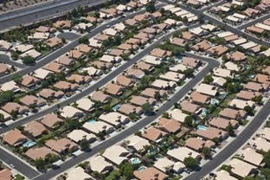

# By doing this, the city can manage its expense easily and can also be more efficient during keeping track of taxes. There will be good population control and more room for open space and agriculture, which every city requires.

# EFFECTS OF URBAN SPRAWL

# **Increased Air Pollution** - Urban sprawl increases car and truck traffic by creating longer and more frequent commutes, which leads to a major increase in air pollution and ground-level smog. Vehicles are the number one cause of air pollution in many urban areas with serious implications for public, wildlife and ecosystem health. According to the Union of Concerned Scientists, "Poor air quality increases respiratory ailments like asthma and bronchitis, heightens the risk of life-threatening conditions like cancer, and burdens our health care system with substantial medical costs." As Americans spend the equivalent of 55 eight-hour workdays behind the wheel every year and urban areas continue to sprawl, more time is spent in cars and more traffic congestion occurs over a larger area, which contributes to the growing emissions of greenhouse gases and the continued degradation of air quality in urban area

**Increased Water Pollution** - Urban sprawl increases water pollution as rain water picks up gasoline, lawn chemicals, heavy metals, paints spills, motor oil, pet wastes, construction site erosion and other pollutants in runoff from lawns, driveways, roads and parking lots, which can eventually travel in large, concentrated amounts, polluting nearby water sources, such as a stream, river or lake

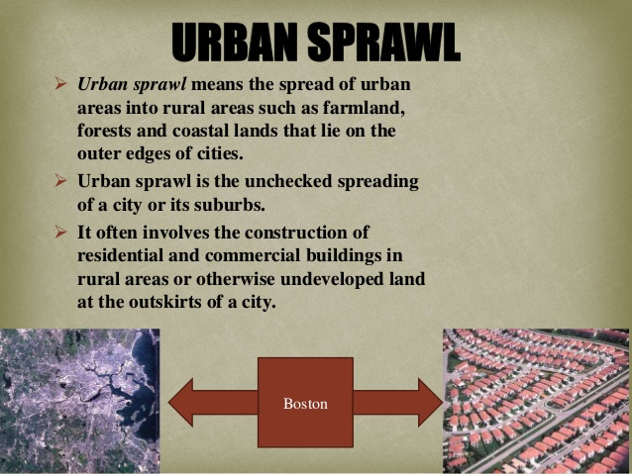

**Increased Water Consumption** - Urban sprawl can create water distribution issues and lead to water over-consumption as more water is consumed for lawn watering and other landscape activities, which can strain and deplete local water supply systems. According to the EPA, "An American family of four can use 400 gallons of water per day, and about 30 percent of that is devoted to outdoor uses. More than half of that outdoor water is used for watering lawns and gardens. Nationwide, landscape irrigation is estimated to account for almost one-third of all residential water use, totaling more than 7 billion gallons per day. Other residential outdoor uses include washing automobiles, maintaining swimming pools, and cleaning sidewalks and driveways.

**Degraded Human Health** - Poor community design, such as poorly planned, low-density, auto-dependent development, makes it more difficult for people to get physical activity and maintain a healthy weight. There is a clear correlation between urban sprawl and the epidemic levels of obesity and increase of chronic diseases associated with physical inactivity. A Smart Growth America study compared the county sprawl index to the health characteristics of more than 200,000 individuals living in the 448 counties and found that people living in counties marked by sprawling development are likely to walk and bike less, weigh more, drive more, have a higher body mass index (BMI) and suffer more from hypertension

**Wasted Tax Money and Crowded Schools** - Instead of improving existing communities, U.S. tax money subsidizes new sprawling developments and communities, costing counties and cities millions of dollars for new schools, water and sewer lines and increased fire and police protection, which forces higher taxes on existing residents. As homes and businesses spread out farther apart, the costs of providing community services increase, forcing local governments to provide for widely spaced services and residents of these communities to subsidize them with higher taxes at the local, state and federal level. Moreover, according to the Sierra Club, "Sprawl creates crowded schools in the suburbs and empty, crumbling schools in center cities

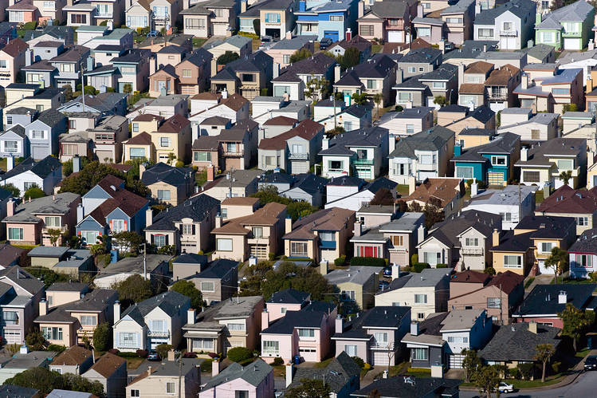

**Loss in Open Space, Parks, Farmland and Wildlife Habitats** - Urban sprawl threatens productive farmland, transforms parks and open spaces into highways and strip malls and destroys more than one million acres of parks, farms and open space each year. As sprawling neighborhoods and highways engulf open space, the natural habitats of wildlife are disappearing beneath the concrete, which is threatening important ecosystems in the U.S. and around the world, such as the Chesapeake Bay, the Everglades and the San Fransisco Bay, and is among the biggest threats to endangered plants as well. In its path, sprawl consumes thousands of acres of forests and farmland, woodlands and wetlands. Each year an area about one kilometer wide and stretching from San Francisco to New York is lost to development in the United States.

# 3.ENVIRONMENTAL ETHICS

# In environmental philosophy, environmental ethics is an established field of practical philosophy "which reconstructs the essential types of argumentation that can be made for protecting natural entities and the sustainable use of natural resources." The main competing paradigms are anthropocentrism, physiocentrism (called ecocentrism as well), and theocentrism. Environmmental ethics exerts influence on a large range of disciplines including environmental law, environmental sociology, ecotheology, ecological economics, ecology and environmental geography.

# There are many ethical decisions that human beings make with respect to the environment.

# For example:

# *Should humans continue to clear cut forests for the sake of human consumption?

# *Why should humans continue to propagate its species, and life itself?

# *Should humans continue to make gasoline-powered vehicles?

# * environmental obligations do humans need to keep for future generations?

# *Is it right for humans to knowingly cause the extinction of a species for the convenience of humanity?

# *How should humans best use and conserve the space environment to secure and expand life?

# *What role can Planetary Boundaries play in reshaping the human-earth relationship?

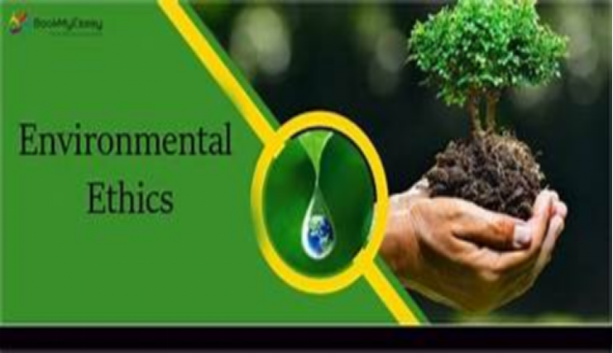

# The academic field of environmental ethics grew up in response to the works of Rachel Carson and Murray Bookchin and events such as the first Earth Day in 1970, when environmentalists started urging philosophers to consider the philosophical aspects of environmental problems. Two papers published in Science had a crucial impact: Lynn White's "The Historical Roots of our Ecologic Crisis" (March 1967) and Garrett Hardin's "The Tragedy of the Commons" (December 1968). Also influential was Garett Hardin's later essay called "Exploring New Ethics for Survival", as well as an essay by Aldo Leopold in his A Sand County Almanac, called "The Land Ethic," in which Leopold explicitly claimed that the roots of the ecological crisis were philosophical (1949)

# The first international academic journals in this field emerged from North America in the late 1970s and early 1980s – the US-based journal Environmental Ethics in 1979 and the Canadian-based journal The Trumpeter: Journal of Ecosophy in 1983. The first British based journal of this kind, Environmental Values, was launched in 1992.

# Contents:

# 1 Marshall's categories

# 1.1 Libertarian extension

# 1.2 Ecologic extension

# 1.3 Conservation ethics

# 2 Humanist theories

# 3 Applied theology

# 4 Anthropocentrism

# 5 Status of the field

# 6 Relationship with animal ethics

# Marshall's categories:

# Some scholars have tried to categorise the various ways the natural environment is valued. Alan Marshall and Michael Smith are two examples of this, as cited by Peter Vardy in "The Puzzle of Ethics." According to Marshall, three general ethical approaches have emerged over the last 40 years: Libertarian Extension, the Ecologic Extension, and Conservation Ethics.

# **Libertarian extension**:Marshall’s libertarian extension echoes a civil liberty approach (i.e. a commitment to extending equal rights to all members of a community). In environmentalism, the community is generally thought to consist of non-humans as well as humans.Andrew Brennan was an advocate of ecologic humanism (eco-humanism), the argument that all ontological entities, animate and inanimate, can be given ethical worth purely on the basis that they exist. The work of Arne Næss and his collaborator Sessions also falls under the libertarian extension, although they preferred the term "deep ecology". Deep ecology is the argument for the intrinsic value or inherent worth of the environment – the view that it is valuable in itself. Their argument falls under both the libertarian extension and the ecologic extension. Peter Singer's work can be categorized under Marshall's 'libertarian extension'. He reasoned that the "expanding circle of moral worth" should be redrawn to include the rights of non-human animals, and to not do so would be guilty of speciesism. Singer found it difficult to accept the argument from intrinsic worth of a-biotic or "non-sentient" (non-conscious) entities, and concluded in his first edition of "Practical Ethics" that they should not be included in the expanding circle of moral worth. This approach is essentially then, bio-centric. However, in a later edition of "Practical Ethics" after the work of Næss and Sessions, Singer admits that, although unconvinced by deep ecology, the argument from intrinsic value of non-sentient entities is plausible, but at best problematic. Singer advocated a humanist ethics.

# Ecologic extension:

# Alan Marshall's category of ecologic extension places emphasis not on human rights but on the recognition of the fundamental interdependence of all biological (and some abiological) entities and their essential diversity. Whereas Libertarian Extension can be thought of as flowing from a political reflection of the natural world, ecologic extension is best thought of as a scientific reflection of the natural world. Ecological Extension is roughly the same classification of Smith's eco-holism, and it argues for the intrinsic value inherent in collective ecological entities like ecosystems or the global environment as a whole entity. Holmes Rolston, among others, has taken this approach.

# This category might include James Lovelock's Gaia hypothesis; the theory that the planet earth alters its geo-physiological structure over time in order to ensure the continuation of an equilibrium of evolving organic and inorganic matter. The planet is characterized as a unified, holistic entity with ethical worth of which the human race is of no particular significance in the long run.

# **Conservation ethics:**

# Marshall's category of 'conservation ethics' is an extension of use-value into the non-human biological world. It focuses only on the worth of the environment in terms of its utility or usefulness to humans. It contrasts the intrinsic value ideas of 'deep ecology,' hence is often referred to as 'shallow ecology,' and generally argues for the preservation of the environment on the basis that it has extrinsic value – instrumental to the welfare of human beings. Conservation is therefore a means to an end and purely concerned with mankind and inter-generational considerations. It could be argued that it is this ethic that formed the underlying arguments proposed by Governments at the Kyoto summit in 1997 and three agreements reached in the Rio Earth Summit in 1992.

# **Humanist theories:**

# Peter Singer advocated the preservation of "world heritage sites," unspoilt parts of the world that acquire a "scarcity value" as they diminish over time. Their preservation is a bequest for future generations as they have been inherited from human's ancestors and should be passed down to future generations so they can have the opportunity to decide whether to enjoy unspoilt countryside or an entirely urban landscape. A good example of a world heritage site would be the tropical rainforest, a very specialist ecosystem that has taken centuries to evolve. Clearing the rainforest for farmland often fails due to soil conditions, and once disturbed, can take thousands of years to regenerate.

# **Applied theology:**

# File:One Earth one family - Interfaith march in Rome to call for climate action.webm

# Pope Francis’s environmental encyclical Laudato si' has been welcomed by many environmental organisations of different faiths - Interfaith march in Rome to call for climate action

# The Christian world view sees the universe as created by God, and humankind accountable to God for the use of the resources entrusted to humankind. Ultimate values are seen in the light of being valuable to God. This applies both in breadth of scope - caring for people (Matthew 25) and environmental issues, e.g. environmental health (Deuteronomy 22.8; 23.12-14) - and dynamic motivation, the love of Christ controlling (2 Corinthians 5.14f) and dealing with the underlying spiritual disease of sin, which shows itself in selfishness and thoughtlessness. In many countries this relationship of accountability is symbolised at harvest thanksgiving. (B.T. Adeney : Global Ethics in New Dictionary of Christian Ethics and Pastoral Theology 1995 Leicester)

# 

# Abrahamic religious scholars have used theology to motivate the public. John L. O'Sullivan, who coined the term Manifest destiny, and other influential people like him used Abrahamic ideologies to encourage action. These religious scholars, columnists and politicians historically have used these ideas and continue to do so to justify the consumptive tendencies of a young America around the time of the Industrial Revolution. In order to solidify the understanding that God had intended for humankind to use earths natural resources, environmental writers and religious scholars alike proclaimed that humans are separate from nature, on a higher order.Those that may critique this point of view may ask the same question that John Muir asks ironically in a section of his novel A Thousand Mile Walk to the Gulf, why are there so many dangers in the natural world in the form of poisonous plants, animals and natural disasters, The answer is that those creatures are a result of Adam and Eve's sins in the garden of Eden.

# 

# Since the turn of the 20th century, the application of theology in environmentalism diverged into two schools of thought. The first system of understanding holds religion as the basis of environmental stewardship. The second sees the use of theology as a means to rationalize the unmanaged consumptions of natural resources. Lynn White and Calvin DeWitt represent each side of this dichotomy.

# Authors like Terry Tempest Williams as well as John Muir build on the idea that "...God can be found wherever you are, especially outside. Family worship was not just relegated to Sunday in a chapel." References like these assist the general public to make a connection between paintings done at the Hudson River School, Ansel Adams' photographs, along with other types of media, and their religion or spirituality. Placing intrinsic value upon nature through theology is a fundamental idea of Deep ecology.

# 

# **Anthropocentrism:**

# Main article: Anthropocentrism

# Anthropocentrism is the position that humans are the most important or critical element in any given situation; that the human race must always be its own primary concern. Detractors of anthropocentrism argue that the Western tradition biases homo sapiens when considering the environmental ethics of a situation and that humans evaluate their environment or other organisms in terms of the utility for them (see speciesism). Many argue that all environmental studies should include an assessment of the intrinsic value of non-human beings. In fact, based on this very assumption, a philosophical article has explored recently the possibility of humans' willing extinction as a gesture toward other beings. The authors refer to the idea as a thought experiment that should not be understood as a call for action.

# 

# 

**4.POPULATION EXPLOSION**

**INTRODUCTION**

* One of the serious problems India is facing today is ‘Population Explosion’.
* It has become one of the most serious problems our country is facing.
* The current population India is 127 million reported on may15,2015
* China is on top and is on 2nd position with respect to the population.
* Over population has adverse effect on the economy and the environment.
* **POPULATION** :- It is defined as a group of people or animals of a particular kind that live in a space.
* EXPLOSION :- A Sudden and very fast increase.
* POPULATION EXPLOSION :- the rapid growth of world’s population over the past one hundred years result from a difference between the rate of birth and the rate of death. The human population will increase by 1 billion people in the next decade. CAUSES OF POPULATION EXPLOSION
* Decrease death rates was the major reason
* Improvement in public health
* High birth rate.
* Lack of education.
* Migration
* Medical technology, along with gains in education and standards of living with in many developing nations.
* Early marriage and universal marriage.

OVERALL VIEW

In the 20th century, human population has grown much faster than before.Between 1950-1990 population crossed 5 billion mark 92 million every year.In the year 2000 the word population was6.1 billion it is predict to grow 4 times in next 100 year

EFFECTS OF POPULATION EXPLOSION

* Over use of natural resources example: water, land, soil, natural forests.
* increase in food demand.
* increase in waste generation.
* increase demand of medical facilities.
* shortage of education facilities.Other effect like
* unemployment
* increase in crime rate poverty
* energy crisis
* Overcrowding of cities
* child abuse

THEORY OF POPUATION GROWTH

MALTHUSIAN THEORY (1798)

* Human population tend to grow at an exponential rate where as food production tend to very slow growth.
* For stabilizing the population growth we need“positive checks”: famines, disease outbreak and violence.
* “preventive checks” birth control systems

MAXIAN THEORY

Population growth- a symptom rather than cause of poverty, resource depletion population and other problems.Social explanation and oppression of the less privileged people leads to poverty, employment, environment degradation and in turn cause population.

SOCIAL MEASURE

1. minimum age of marriage

2.raising the status of women

3.spread of education

4.adoption

5.social security

ECONOMIC MEASURES

* More employment opportunities
* Development of agriculture and industry
* Standard of living
* Urbanization

OTHER MEASURES

* Late marriage
* Self control
* Self planning
* Recreational facilities
* 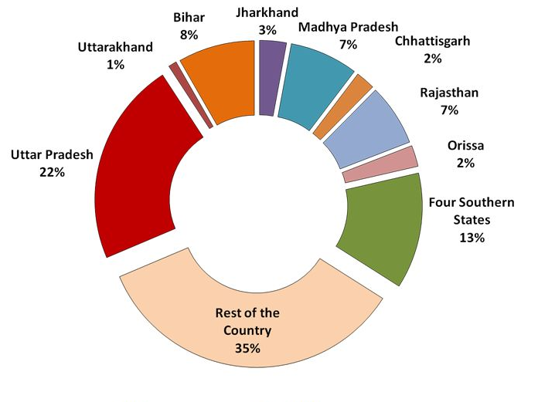Publicity

5.GREEN BUILDINGS

WHAT IS GREEN BUILDING

* Green building is a resource-efficient method of construction that produces healthier buildings which have less impact on the environment and cost less to maintain.
* This sustainable approach to construction accounts for a building’s entire life cycle: siting, design, construction, operation, maintenance, renovation and demolition (read Life Cycle Assessment for more)
* Comprehensive rating systems that certify green buildings, such as LEED, Living Building Challenge and Build Green, measure the sustainability of a building according to a number of criteria. Taken together, these criteria form an accurate picture of what green building is all about. The common criteria are listed below.

SITE

* Sprawl is not sustainable. Green builders are encouraged to build on previously developed land rather than developing new land. It’s also important to build near existing infrastructure, such as bus routes and libraries, to reduce residents’ dependence on transportation, since the effort that goes into building a green home is wasted if the occupants have to commute great distances every day. The smaller the building site the better since there’s less environmental footprint. Sites that have been sustainably landscaped and don’t suffer from soil erosion or light pollution are also considered more sustainable

WATER

* Water reduction is built in by design, using low-flow toilets, greywater systems and xeriscaping. The focus is first on reducing the need for water (i.e. low-flow toilets) then on dealing with water once it has been used (i.e. greywater irrigation). Water collection methods such as rainwater harvesting are also central to sustainable building

ENERGY AND ATMOSPHERE

Green buildings are constructed using energy efficient designs (i.e. passive houses are built with super-insulation and other techniques to ensure a tight building envelope and minimal energy consumption). Processes that make use of clean energy such as geothermal and solar PV systems are also widely used in sustainable building

MATERIALS AND RESOURCES

It’s estimated that as much as one-third of Canada’s total waste is building related. To minimize the impact of this wasteful industry, green builders reduce material usage wherever possible. They also reuse and recycle materials by salvaging, deconstructing, remanufacturing and refurbishing. Preference is given to materials that are durable because they don’t need to be replaced as often. Care is also taken in selecting materials that are sustainably produced, come from natural, renewable sources, and require minimal transportation

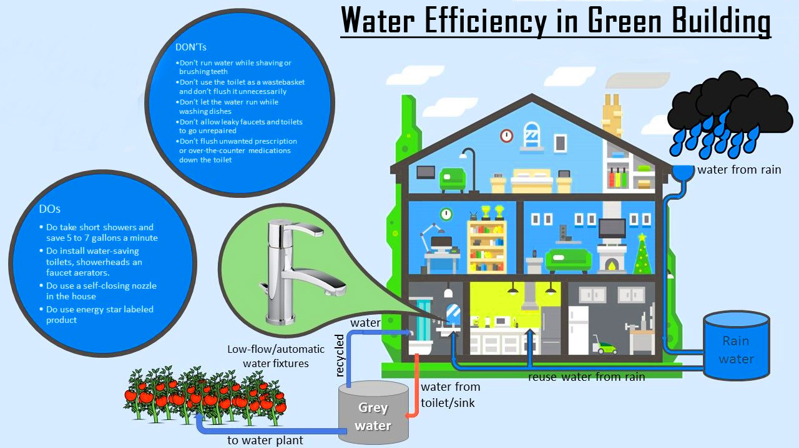

SIZE

* Another aspect the relates to materials and resources is building size. Average living space per Canadian is 700 square feet, a figure that has quadrupled in a generation, according to Eco-home. As a country we have shrunk our family size, but increased our home size. This rapid growth in home size is simply not sustainable. According to 100K : “A 100 per cent increase in home size yields an increase in material usage of 40 to 90 percent… and an increase in annual energy usage of 15 to 50 per cent”
* There’s no specific home or building size that is considered sustainable, but there are guidelines. The LEED Home Size Threshold sets a neutral home building threshold that ranges from 900 to 2850 sq. ft. depending on the number of bedrooms (one to five). Going above the threshold makes it harder to achieve LEED certification, and below, easier

INDOOR ENVIRONMENTAL QUALITY(IEQ)

* Health Canada states that Canadians spend up to 90 per cent of their lives indoors, which means the quality of indoor air is much more important to our health than the quality of outdoor air. Green builders strive to construct buildings that are good not just for the environment, but for our health. Low-emitting materials are encouraged such as zero-VOC paints and formaldehyde-free furnishings. Improved ventilation and moisture-resistant products are also key IEQ attributes
* 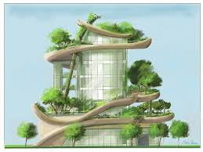Building does not just imply the physical construction of structures. Building also means the development of a neighbourhood, the creation of a park, the redesign of infrastructure. Some consider green building to be a culture of transformation. One forward-thinking example would be the redesign of an entire suburban neighbourhood into a car-free, population dense neighbourhood with easy access to urban agriculture. Living Building Challenge captures this concept of wholistic building best with the provocative question, “What if every single act of design and construction made the world a better place?”

BY

P. AKSHAYA

19R11A0483

ECE -B